Wirework
Create a Web page (HTML5 + CSS3 + images) that looks and behaves like the screenshot below:
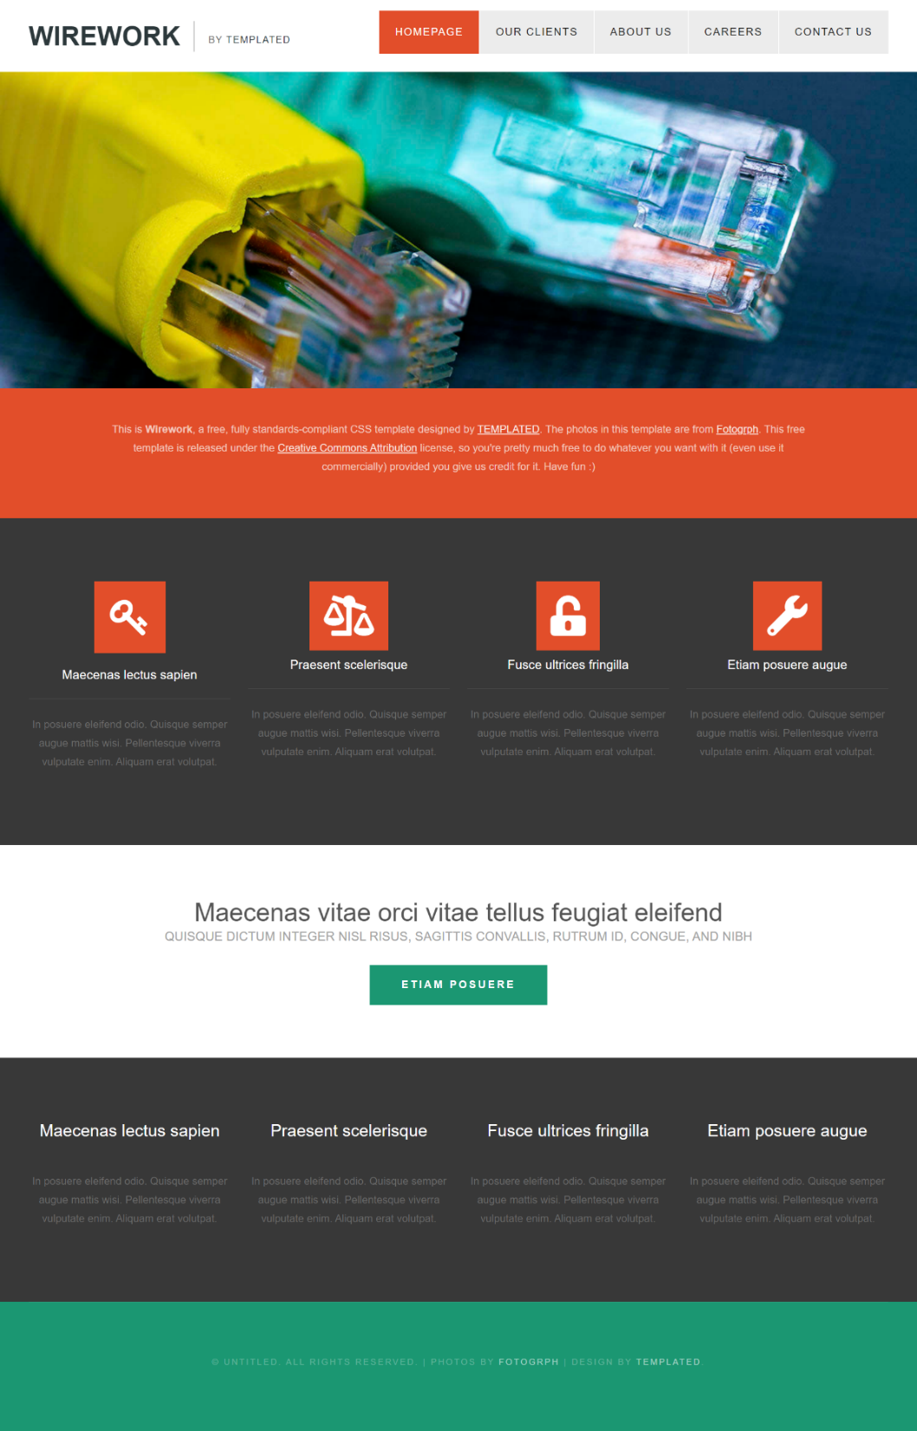
You are given the above screenshots + all required images.

🚀 Output and Submission Format
- The output should be valid HTML5 + CSS3 + images that implement the above web page.
- a link to a publicly hosted version of your webpage (e.g., using GitHub Pages, Vercel, or Netlify).

Constraints
- Use Font Awesome with the icons (wrench, unlock-alt, legal, key)
- Use font 'Helvetica'
- The site should work on mobile devices(Desktop Layout (e.g., Width > 768px):
- The design is not required to be pixel perfect, but should be clean, readable, and functional.

